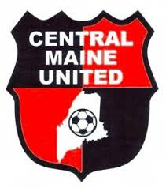
CMU - Coaches Biographies
Ryan Loubier
Title: CMU U13 Boys Premier Coach
Phone: 207-314-0857
Email: rloubier77@gmail.com
Experience:
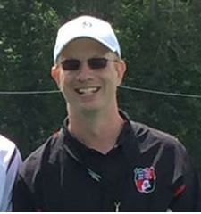

BIO
Coach Loubier was born and raised in Winslow, Maine and graduated in 1996 from Winslow High School. He was captain of his high school team. His junior year, he was selected as a representative of Winslow High School to attend Dirigo Boys State.
After High School he studied Business Management at Thomas College in Waterville, Maine.
Ryan has coached for Winslow Travel Soccer Club since 2012. During that time he has served as an At Large Board Member for WTSC. He is presently the head coach of the WTSC U13 Boys team. He is also a USSF E license holder.
Ryan is happy to be involved with CMU and in his role as a premier coach. He provides high quality training, while creating a positive experience for players, coaches and parents.

