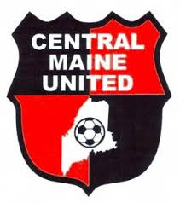
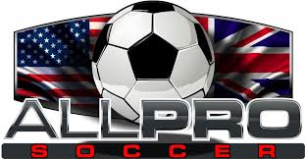
CMU - Coaches Biographies
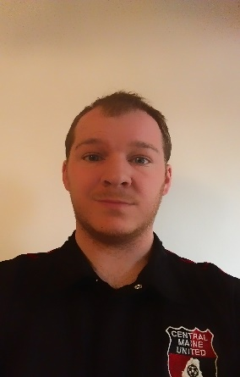
Jarrod Carnick
Title: CMU U13 Boys Premier Coach
Phone:
Email: jcarnrick@gmail.com
Experience:

BIO
Jarrod is an up and coming coach in the Central Maine region. He holds a BA in Communications from Susquehanna University in Pennsylvania.
He is a Winslow Native who played for the Maine Terriers where he was coached by Gary Walker. Jarrod has been the Assistant Boys Varsity coach and head JV coach at Winslow High School for 3 seasons.
He has coached his first premiere club this past spring with the U12 CMU boys, and he looks forward to continuing his involvement with the club.

