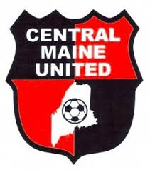
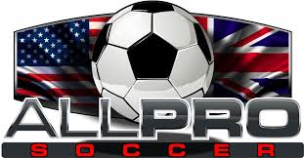
CMU - Coaches Biographies
Eric Warn
Title: CMU – VP Premier, Board Member, coach
Phone: 207649-7002
Email: ewarn@its.jnj.com
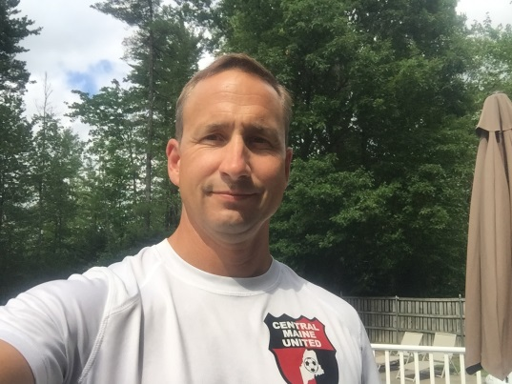

BIO
Eric has served on the CMU board representing member club Winslow travel since the club was developed roughly 7 years ago. Eric currently serves as the VP of the Premier side as well as helping to coach various teams over the years.
Eric holds a Masters of Physical Therapy degree from the University of Colorado as well as a BA in Business from Ohio Wesleyan University. As a Physical Therapist Eric worked for Denver Bronco Sports medicine and also held the CSCS strength and conditioning designation from the National Academy of Sports Medicine.
Currently Eric works full time in the medical equipment field as a sales consultant in the areas of Orthopedic Trauma and Spine.
Eric has been coaching for both Winslow Travel and CMU over the years highlighted by winning the State cup with the U12 girls team in 2015 and attending Regionals in West Virginia to represent Maine.

Playing Achievements
Eric grew up in NY playing in and around the NY City area for Wallkill United who won the Metropolitan Division of the Cosmopolitan League in the 80’s. Eric went on to play for Division 3 powerhouse Ohio Wesleyan from 1985-1988. During that time Ohio Wesleyan was the winningest men’s soccer team in the NCAA regardless of Division with a winning percentage of .815. While at Ohio Wesleyan Eric earned first team all NCAC, all Ohio and all Mideast honors and was captain in his senior year in helping the Bishops win the NCAC and competing in the NCAA tournament all 4 years. Eric completed his formal playing days competing in the Empire State Games men’s division.

